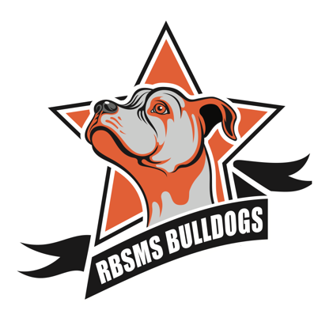
Raymond B. Stewart Middle School
REGISTRATION PACKET
2021 - 2022
WE ARE BULLDOG STRONG!
Due to the COVID-19 virus we are a Traditional and my School Online learning school at this time. We are still enrolling students however, please email our Registrar Cheryl Pelletier at cpelleti@pasco.k12.fl.us for any questions or concerns.

REQUIRED DOCUMENTS IN ORDER TO BE ENROLLED AT RAYMOND B. STEWART MIDDLE SCHOOL!

IN- STATE AND OUT OF STATE TRANSFERS

- Proof of residency for RBSMS Zone- 3 documents required- current utility bill, lease, mortgage statement, driver’s license, etc. (PO Boxes not accepted). Document must have name and address to be accepted.
- Health Records- including birth certificate, Florida Certificate of Immunization (all 7th graders need a Tdap immunization), physical form, medical needs
- Any Exceptional Student Education records/testing- including IEP, 504, testing, ELL/ESOL, or additional services your student may need.
- Withdraw forms, or report cards and transcripts from previous school
- Any custodial or legal documentation or placement paperwork for student

PASCO COUNTY SCHOOLS TRANSFER OR SCHOOL CHOICE

- Proof of residency for RBSMS Zone—see above- or school choice letter
- Release of records signed for transfer of student records

All families will complete registration packet, and course card prior to enrollment

