How to use esembler

- Enter the following on your address line: https://grades.pasco.k12.fl.us
- You will see this: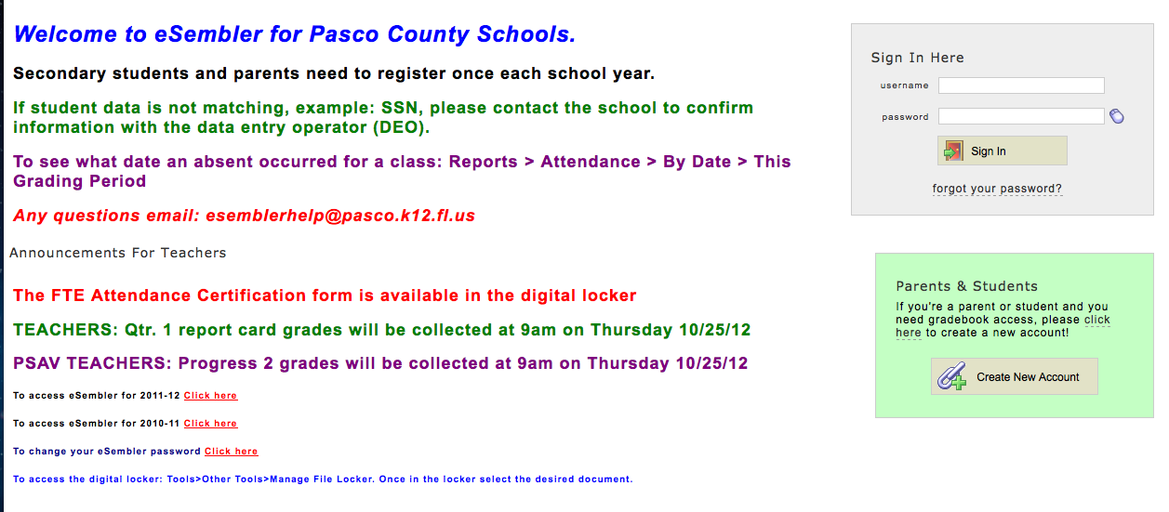
- If you already have an account, enter your username and password in the sign-in box. If you don’t have an account, click on the following: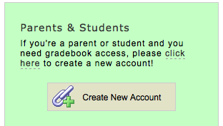
- Once you have clicked on the “Create new account” button above, you will be taken to this screen: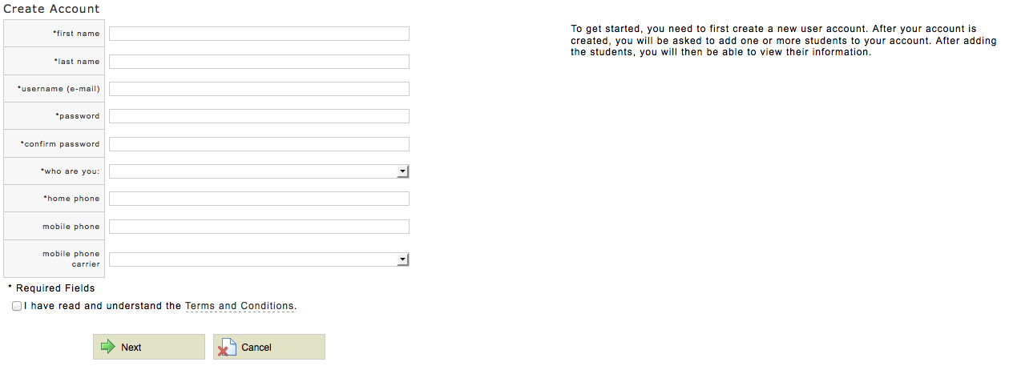
- All of the lines with a * beside them MUST be filled out to create an account. Please use an actual email account, because a link will be sent to this email address before your account can be activated. The link you will receive looks like this:
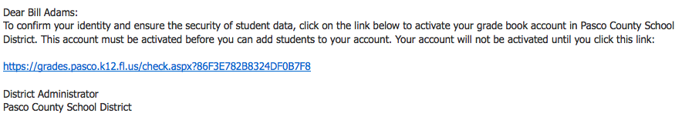
- Once you click on this link, you will be taken back to the start page. You will have a message above the sign in box saying “You have successfully Activated Your Account”
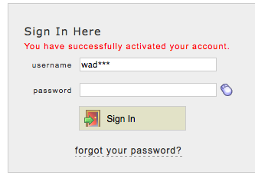
- Log in using the email address and password you created in step 4.
- We’re almost done creating your account!! After you log in on step 7, you will be taken to this screen: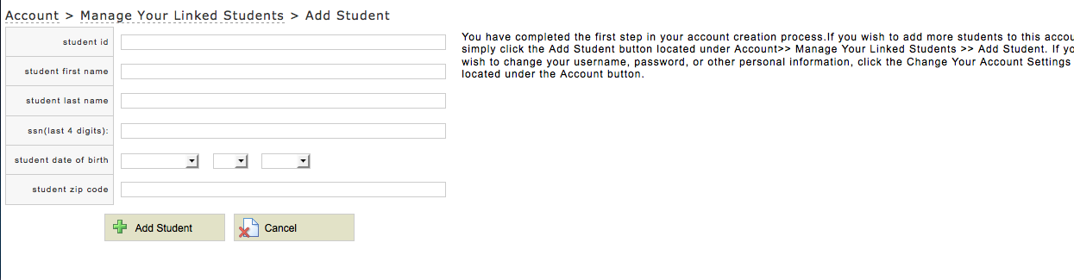
- Fill in all of the information, and you have now created an account!

