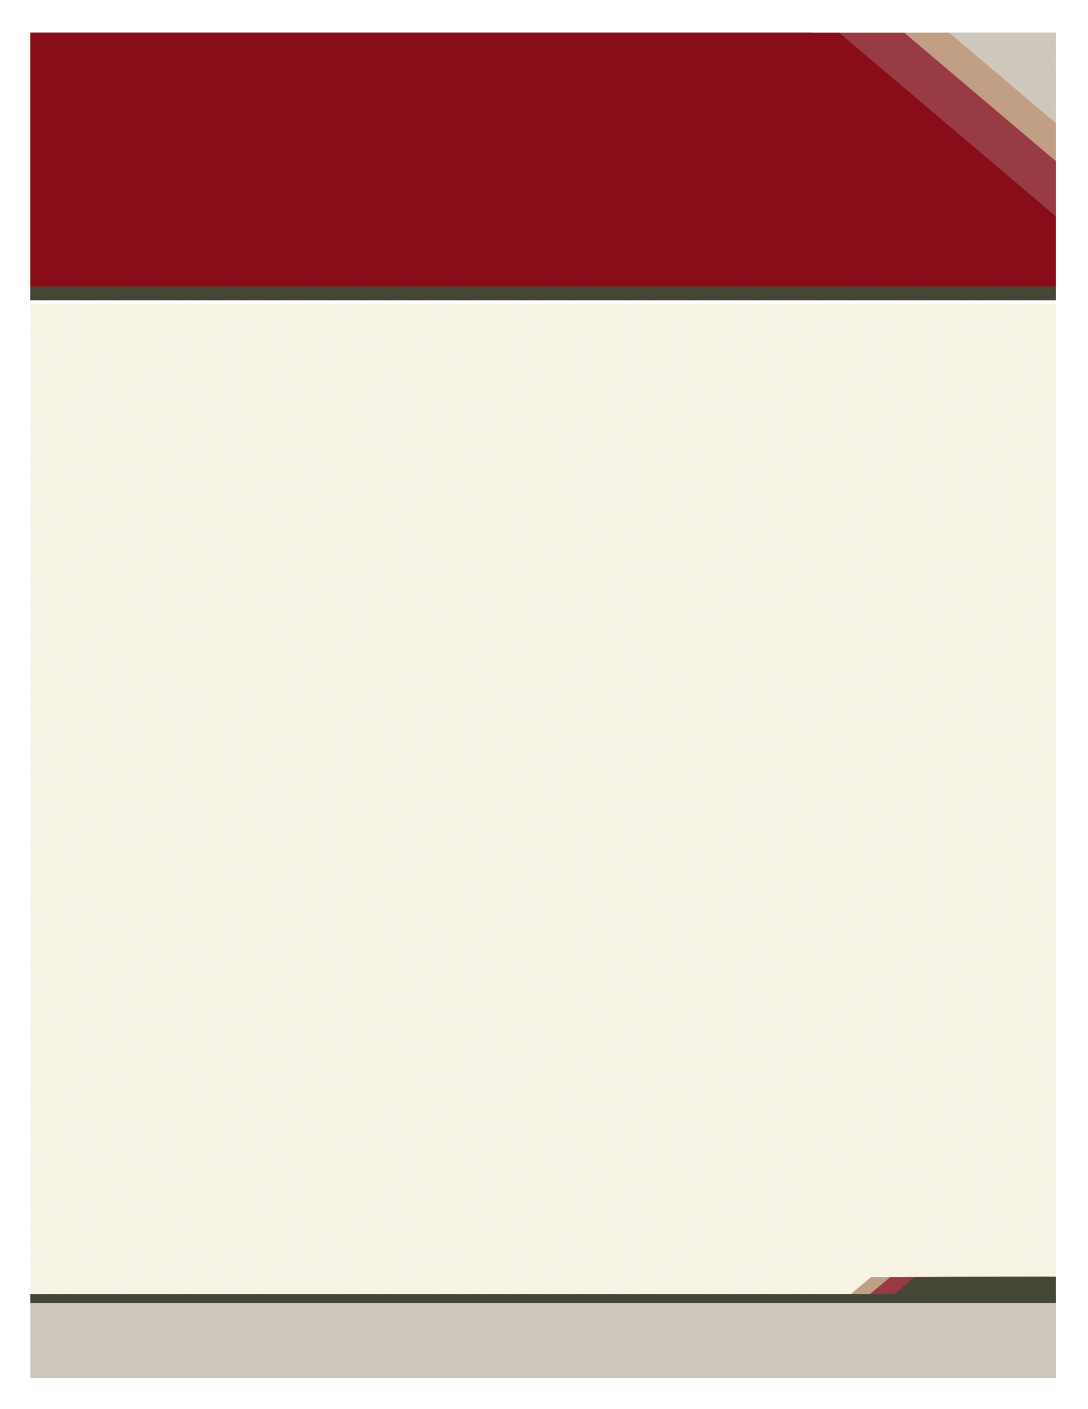

***Community Connections***

***Parent Night***

**R. B. Stewart Middle School**

Enter Contact Information Here | 1127 Lombard Blvd. San Francisco, CA 59802 | phone 555.555.5555 | fax 555.555.5555

­

**PRESENTATIONS**

**5:00 P.M. – 7:30 P.M.**

**Art Exhibit:** Join us for our Second Quarter Art Show. Art from Exploring 2D Art and Art in World Cultures classes will be shown in the Lobby of building 10. Come see what Art has to offer. (5:00-7:30 ongoing)

**AVID Presentation**

TRF?  POC? Inquiry?  What do these look like in the AVID Elective?  Tutorials are an important part of the AVID Elective.  Join us during Community Connections to explore and participate in mock tutorials.  These sessions are reserved for those in the AVID Elective. (5:00, 5:30) 07-04

**myStudent:** This session will assist parents in accessing their child’s grades through the gradebook program, myStudent. Parents will receive step-by-step directions for accessing the program. (5:30, 6:00, 6:30) Bldg 10 lab

**Science Fair Projects** – Stop by the Media Center to view the science projects that were entered into the 2018 RBSMS Science Fair. (5:00-7:30 ongoing)

**Holiday Card Making** Stop by and make a holiday card for members of the Military. (5:00-7:30 ongoing) 7-014

**Maker Space Creations:** Come check out the newest learning space at RBSMS. This space will be used throughout the year for students to make projects and connect with their learning. It increases student engagement by placing an emphasis on project based learning and giving students more choice in how to show mastery of content standards. Stop by the school’s new makerspace to explore the latest educational technology hands on and explore the possibilities. Stations include: 3D pens, Merge Cubes, Sphero Robotic Cubes, Little Bits, and more. Open 5:00-7:30

We are very excited to invite you to participate in our second Community Connections event of the 2019-2020 school year, which will take place on December 3rd, at R. B. Stewart Middle School.

Parents will have the opportunity to schedule a conference with their child's teachers and meet at a designated time during the evening.  We also have many exciting stem presentations that parents will want to attend.

Parents and students who attend our Community Connections event can earn **Two PBIS** bonus points for **each** session they attend.  Community Connections event on Tuesday, December 3rd.

It is an evening you won't want to miss!

Call Lynette Washburn RBSMS Parent Involvement Coordinator at 813-794-6510 for information

.

**PARENT CONFERENCES**

**4:00 P.M. – 8:00 P.M.**

Are you struggling to find time to schedule a parent conference with your child’s teacher?

If you would like to set up a conference to meet with your student’s teachers, please see the back of this flyer. Conferences must be booked in advance by returning the reservation form on the back.

**tuesday, December 3, 2019**

Join us for a light dinner in

front of the cafeteria at no charge.

To find out more information about this event, please visit our website at: **http://rbsms.pasco.k12.fl.us**