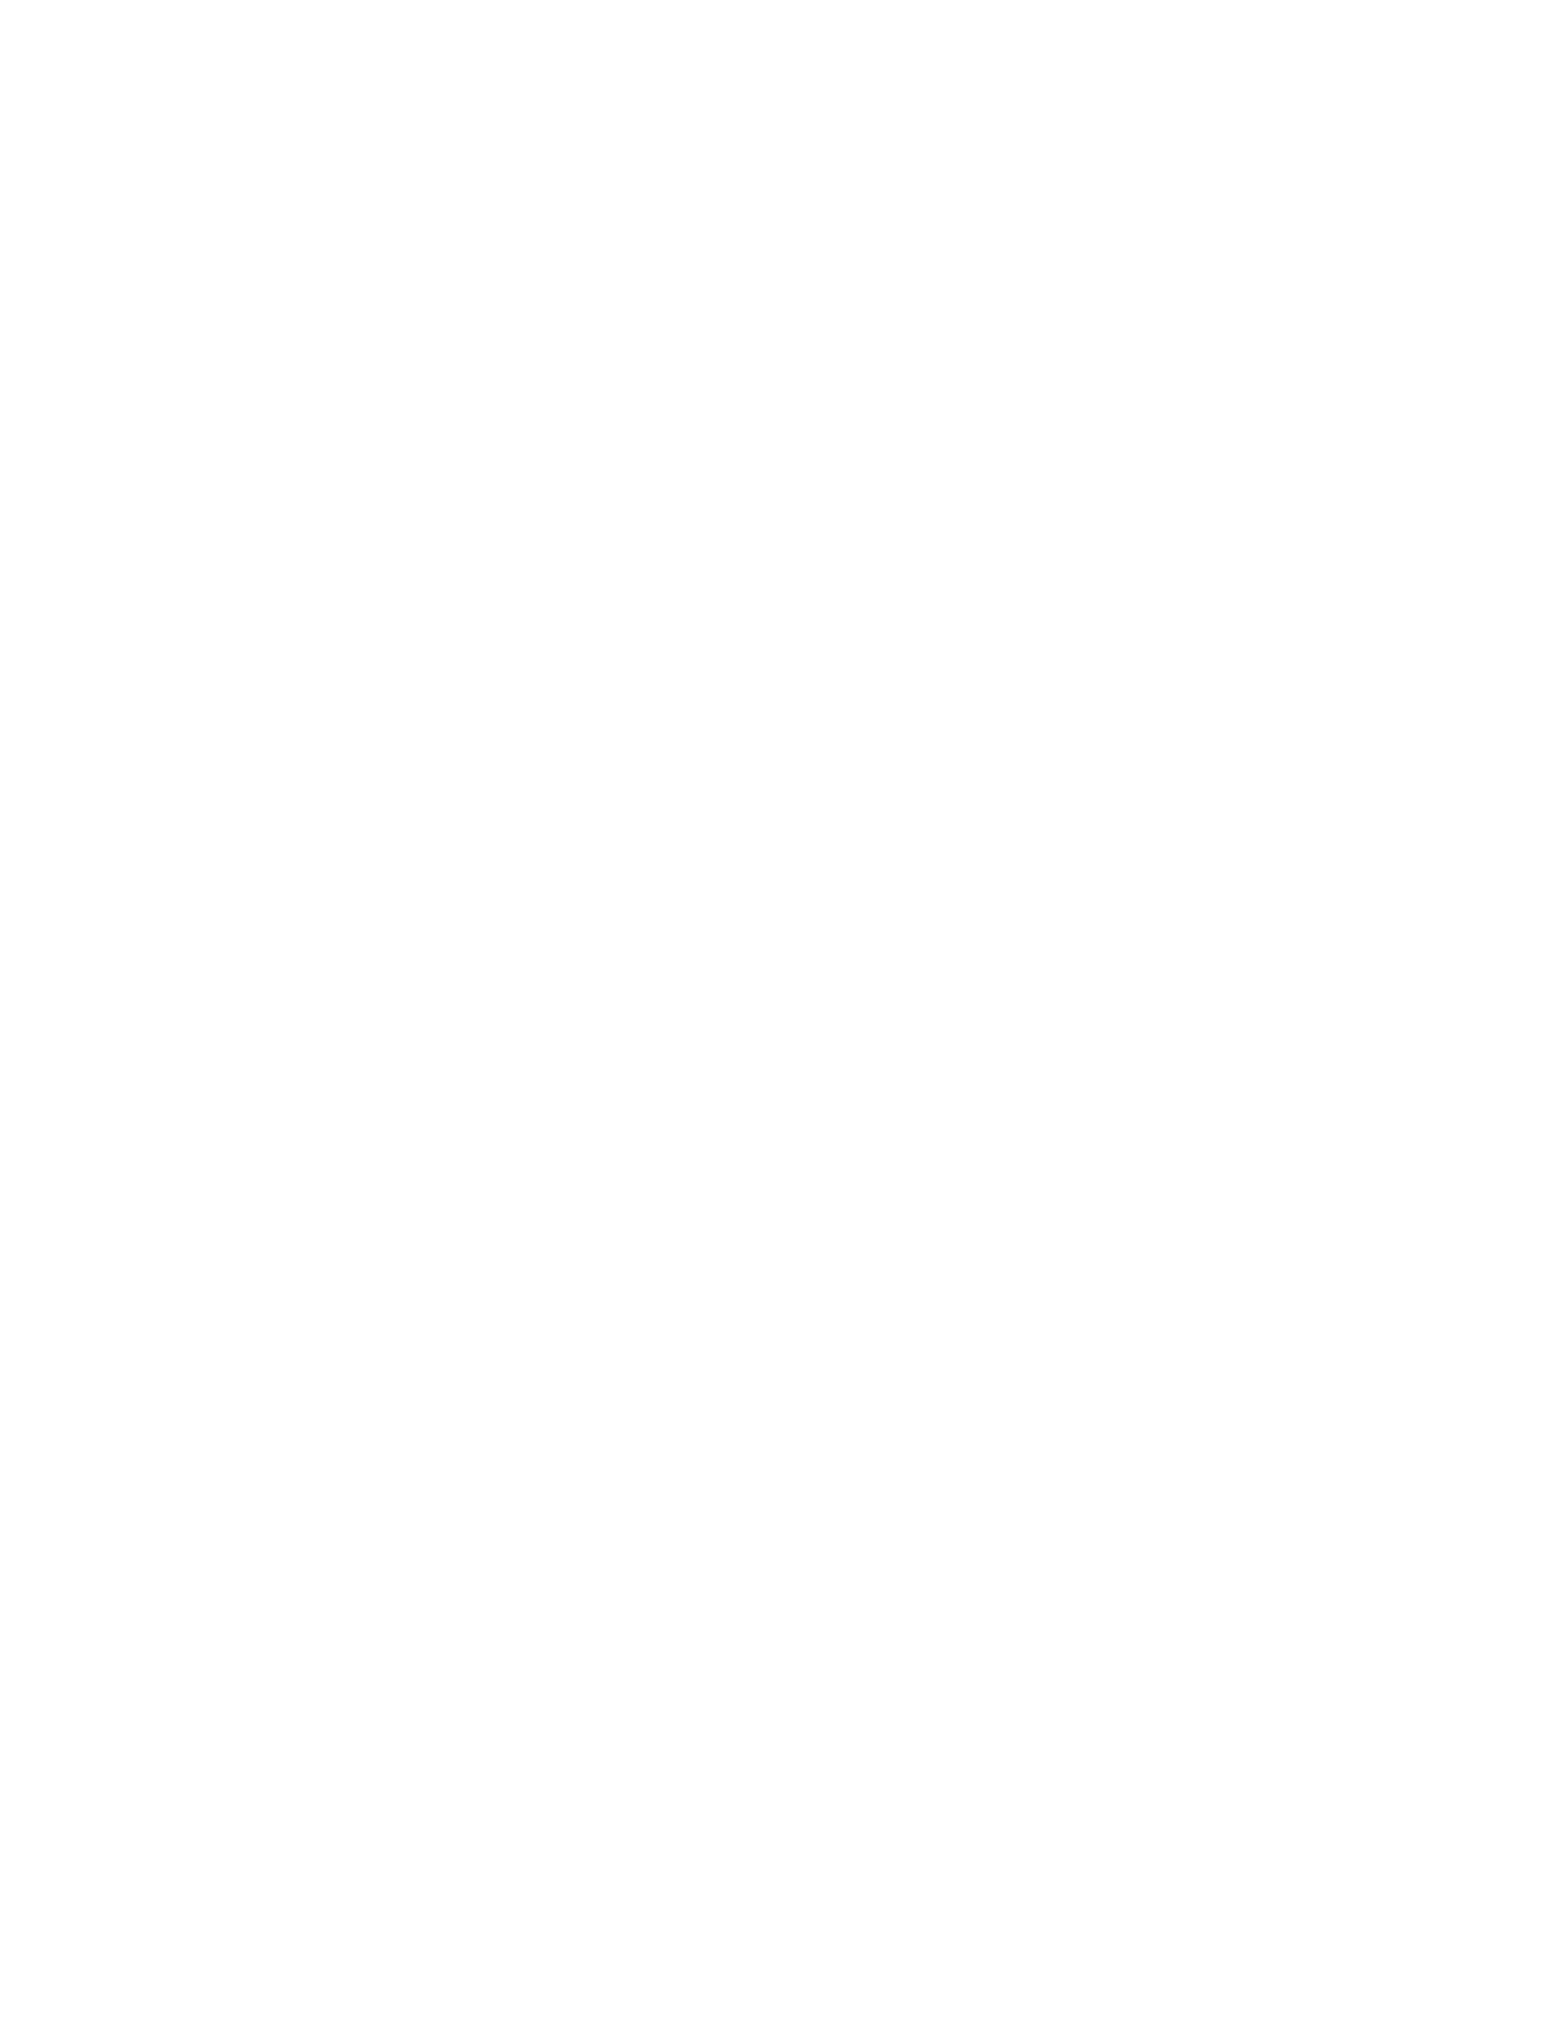

***Community Connections***

R.B. Stewart Middle School

Enter Contact Information Here | 1127 Lombard Blvd. San Francisco, CA 59802 | phone 555.555.5555 | fax 555.555.5555

­

**Tuesday, December 3**



**myStudent –** This session will assist parents in accessing their child’s grades through myStudent. Parents will receive step-by-step directions for accessing the program, as well as how to navigate the site.

* Times: 5:30, 6:00, 6:30 Lab Bldg 10

**Art Exhibit –** Join us for our Second Quarter Art Show. Art from Exploring 2D Art and Art in World Cultures classes will be shown in the Lobby of building 10. Come see what Art has to offer.

* Times: 5:00-7:30 ongoing Lobby Bldg 10

**AVID** – TRF?  POC? Inquiry?  What do these look like in the AVID Elective? Tutorials are an important part of the AVID Elective.  Join us during Community Connections to explore and participate in mock tutorials. Sessions are reserved for those in the AVID Elective. 07-04

* Times: 5:00, 5:30

**Science Fair Projects -** Stop by the Media Center to view science projects that were entered in the 2019 RBSMS Science Fair. (5:00-7:30 ongoing)

* Time: 5:00-7:30 ongoing

**Holiday Card Making -** Stop by and make a holiday card for members of the Military.

Time: 5:00-7:30 ongoing7-014

**Maker Space Creations:** Come check out the newest learning space at RBSMS. This space will be used throughout the year for students to make projects and connect with their learning. It increases student engagement by placing an emphasis on project based learning and giving students more choice in how to show mastery of content standards. Stop by the school’s new makerspace to explore the latest educational technology hands on and explore the possibilities. Stations include: 3D pens, Merge Cubes, Sphero Robotic Cubes, Little Bits, and more. Open 5:30-7:00 Media-Maker Space Room

Parents who are interested in scheduling after hour parent conferences should complete the Conference Request form at the bottom of this letter and return it to the back office ASAP. At least two teachers from each team will be present for our Parent Conferences and they will be able to share grade/behavior information for your child’s classes in twenty-minute blocks. Parent Conferences will take place in the cafeteria and they will begin at 4:00 p.m. and will end at 7:50 p.m. You **MUST** register ahead of time to schedule a conference and a confirmation letter will be sent to you with the time your conference is scheduled. If you have questions about scheduling a conference, please contact Lynette Washburn, RBSMS Parent Involvement Coordinator at 813-794-6510.

---------------------------------------------------------------------------------------------------------------------------------------------------------

Parent Conference Request Form

Parent/Guardian Name___________________________________________________________________________________

Phone Number__________________________________E-mail__________________________________________________

Child’s Name ____________________________________________Team ________________________________________

Circle Top **Three** Preferences for Parent Conference Time:

4:00 4:30 5:00 5:30 6:30 7:00 7:30

Each team is limited to seven conferences. The school will contact you if your request for a Parent Conference can be honored. If you are in need of translation services, please let us know.

Parent Conferences: 4:00 – 8:00 p.m.

Information Sessions:

**5:00 P.M. – 7:30 P.M.**

Sessions start every half hour and are 20 minutes long.

The last session begins at 7:00 pm.